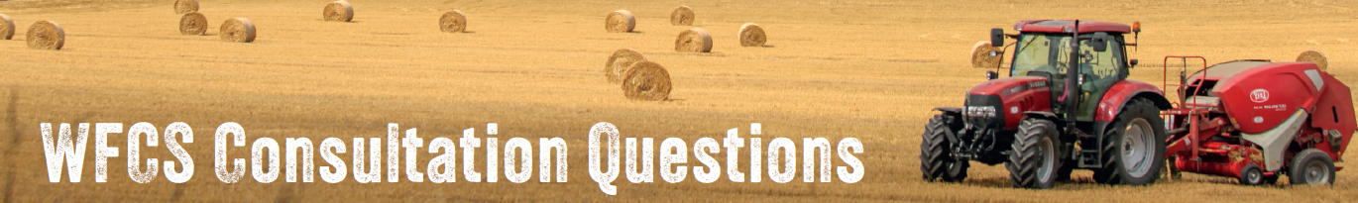
Question 1: Do you support a scheme which gives farmers flexibility to apply for support that matches their business model and not a one size fits all model?
Yes □ No □ Not sure □
[If you would like to, please expand on your answer here…]

Question 2: Do you think your agricultural business is sustainable and viable on the current proposed SFS model of costs incurred/income foregone?
Yes □ No □ Not sure □
[If you would like to, please expand on your answer here…]

Question 3: Do you think that a minimum support of 70% of the current BPS, with the ability to top-up to 100% funding is the right approach to encourage farmers to improve and preserve the environment and drive up food production standards?
Yes □ No □ Not sure □
[If you would like to, please expand on your answer here…]

Question 4: What specific actions should be included as mandatory "universal actions" under the 70% baseline payment?
[Please give your answer here…]

Question 5: How can the WFCS scheme best balance the need for food production with environmental sustainability?
[Please give your answer here…]

Question 6: How can the WFCS scheme best support farmers in adopting sustainable land management practices that improve soil health and carbon sequestration?
[Please give your answer here…]

Question 7:What do you think should be the priority of the optional aspects?
Animal Welfare □ Supporting young farmers □ Climate change □
Protecting SSSIs □ Habitat creation □ Tree/hedgerow planting □
Woodland management □ Capital investment □ Other – please write below □

Question 8: How can the application process for optional actions be streamlined to reduce bureaucracy for farmers?
[Please give your answer here…]

Question 9: How do you think we can encourage more young people into farming?
[Please give your answer here…]

Question 10: How can we best address Common land issue?
[Please give your answer here…]

Question 11: How should this scheme address SSSI land?
[Please give your answer here…]

Question 12: Should farms which receive funding give access to public rights of way?
Yes □ No □ Not sure □
[If you would like to, please expand on your answer here…]

Question 13: How would you define an active farmer?
[Please give your answer here…]

Question 14: Do you think there should be a minimum size farm to trigger government support?
Yes □ No □ Not sure □
How many acres should a farm be to receive support?

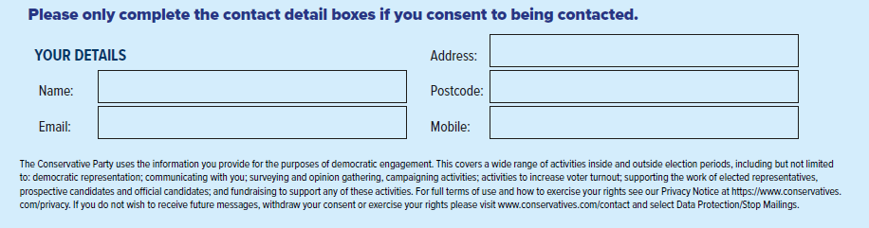
Question 15: Are there any other issues or considerations not addressed in this consultation that you believe are important for the future of Welsh agriculture?

[Please give your answer here…]

